PS&E Draft Proposal
USER GUIDE
Navigate
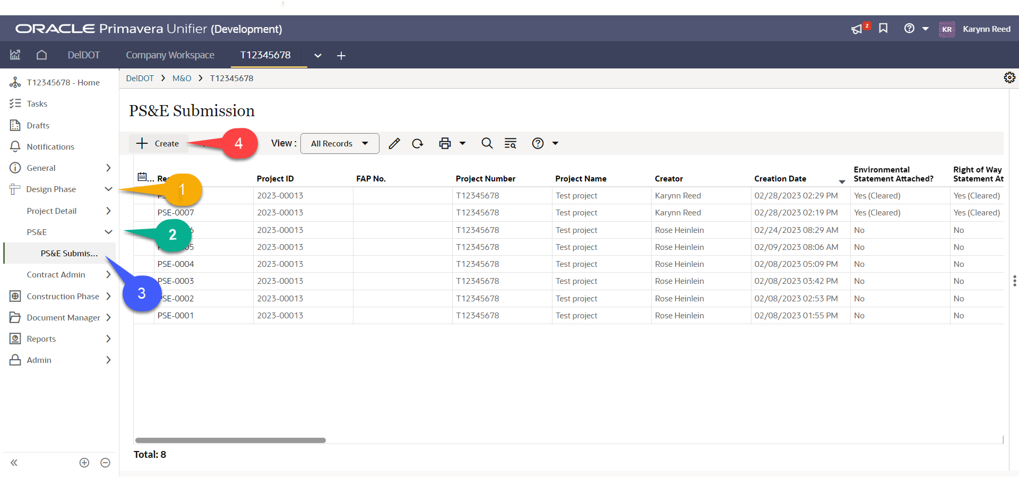
- In a Unifier project, expand Design Phase folder on the navigation pane to the left and click PS&E – PS&E Submission to go to PS&E Submission module
- Click + Create to start a new PS&E record

Create
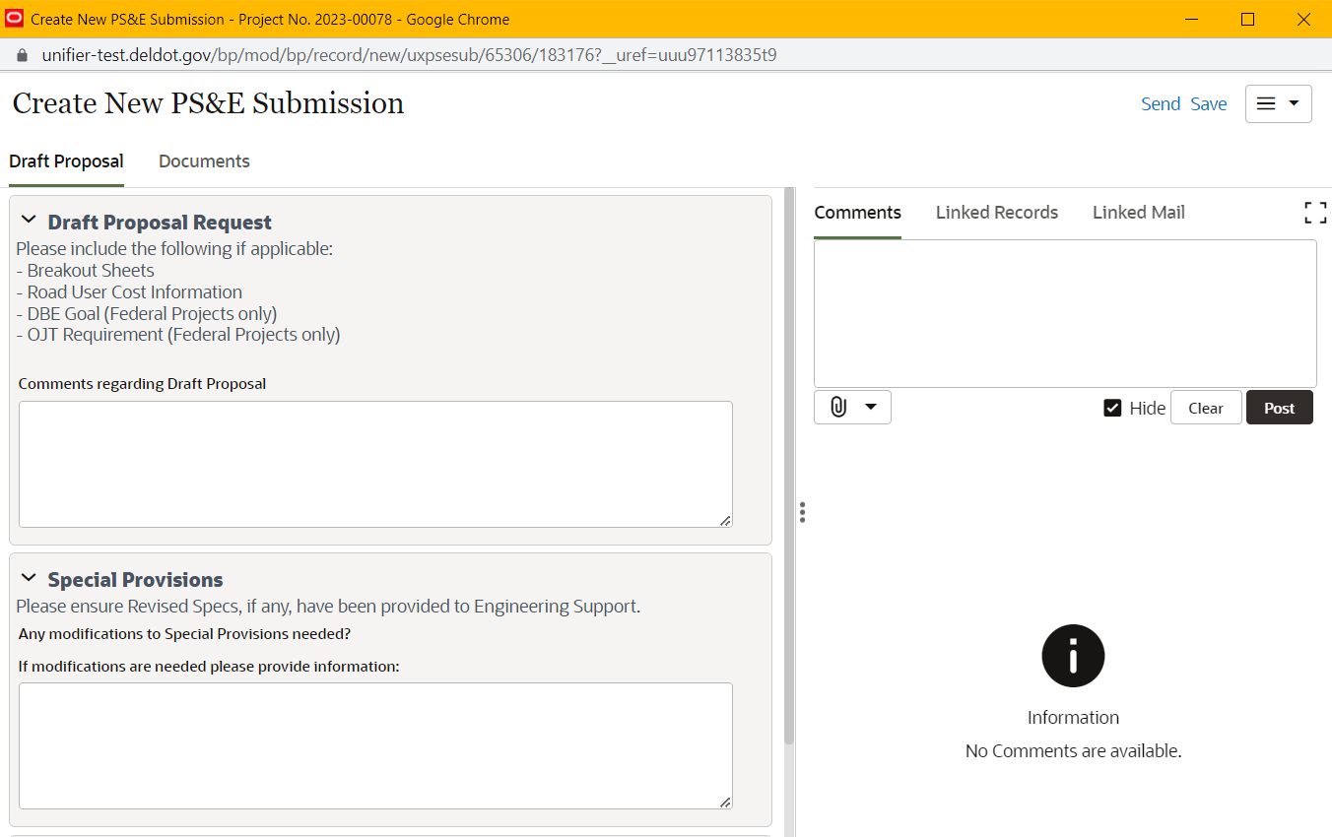
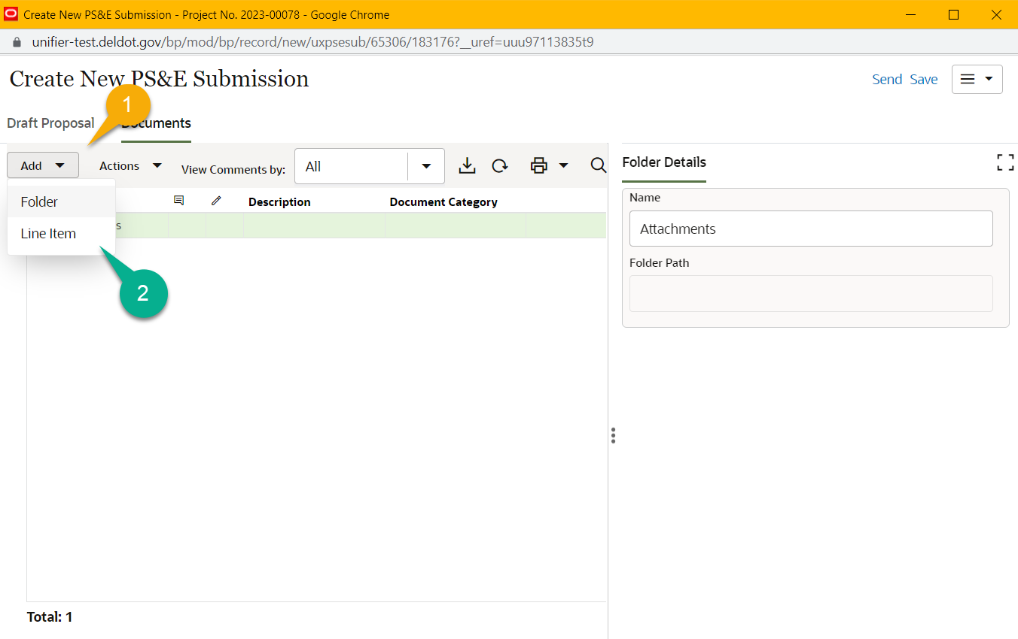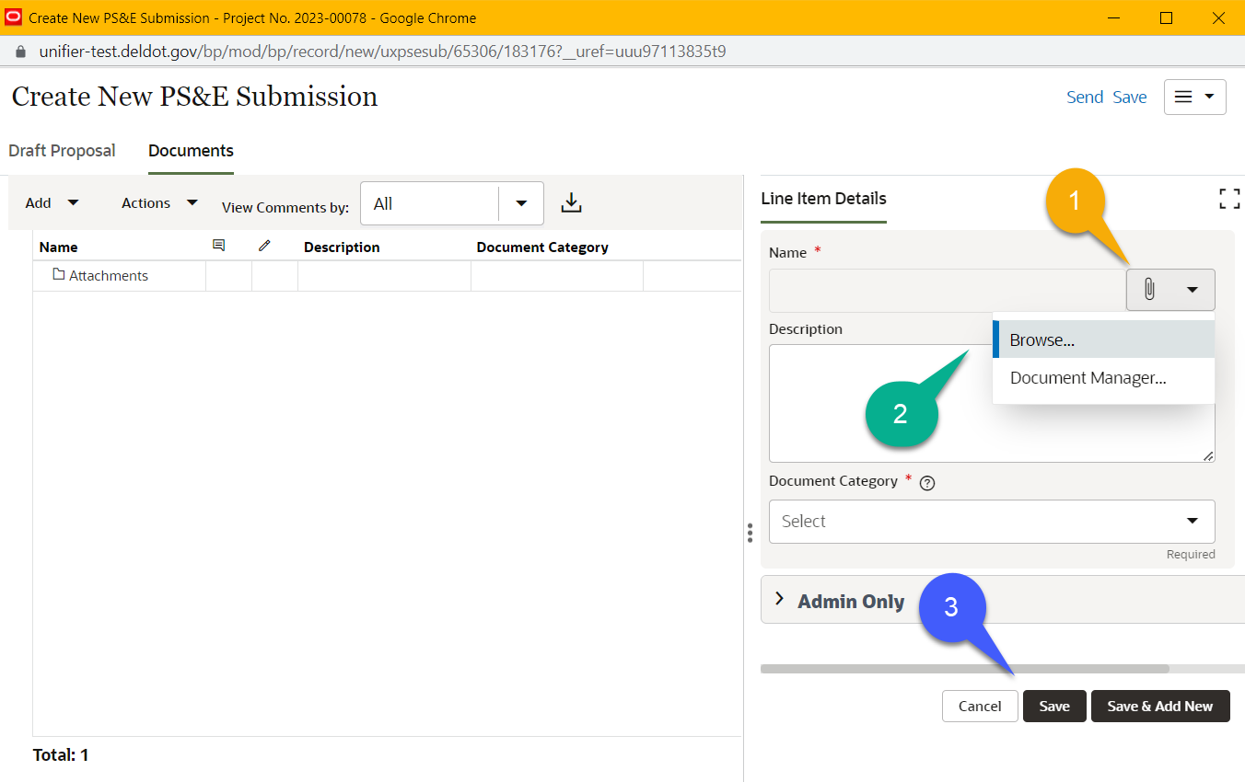
- Draft Proposal Request: attach any needed files in the documents tab and leave a comment of any items to be noted
- Special Provisions: Add any comments for Special Provisions and make sure to inform Engineering Support
- Documents:
  - Click on the Add button then click Line Items
  - On the right hand side click on the Paperclip and Browse the for the documents
- Once ready to request the Draft Proposal click on Send in the upper right hand corner
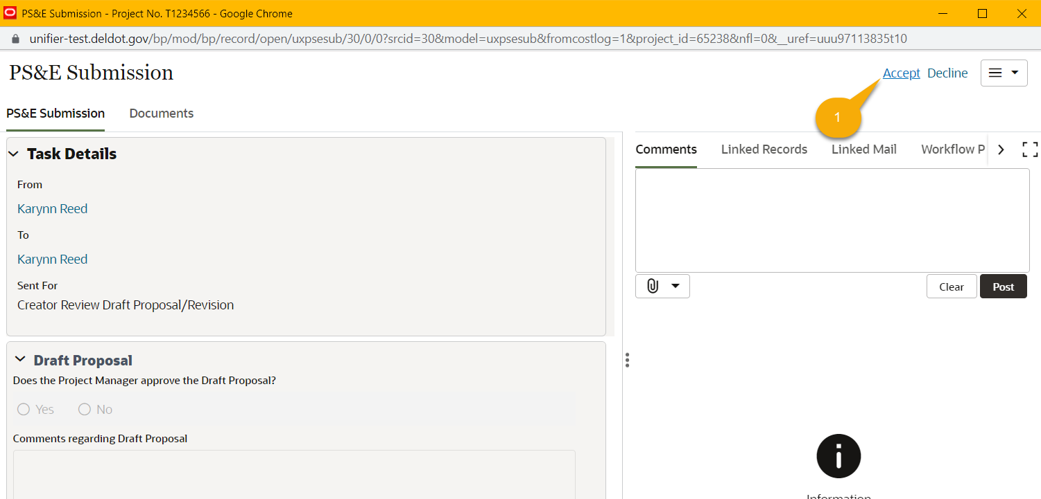

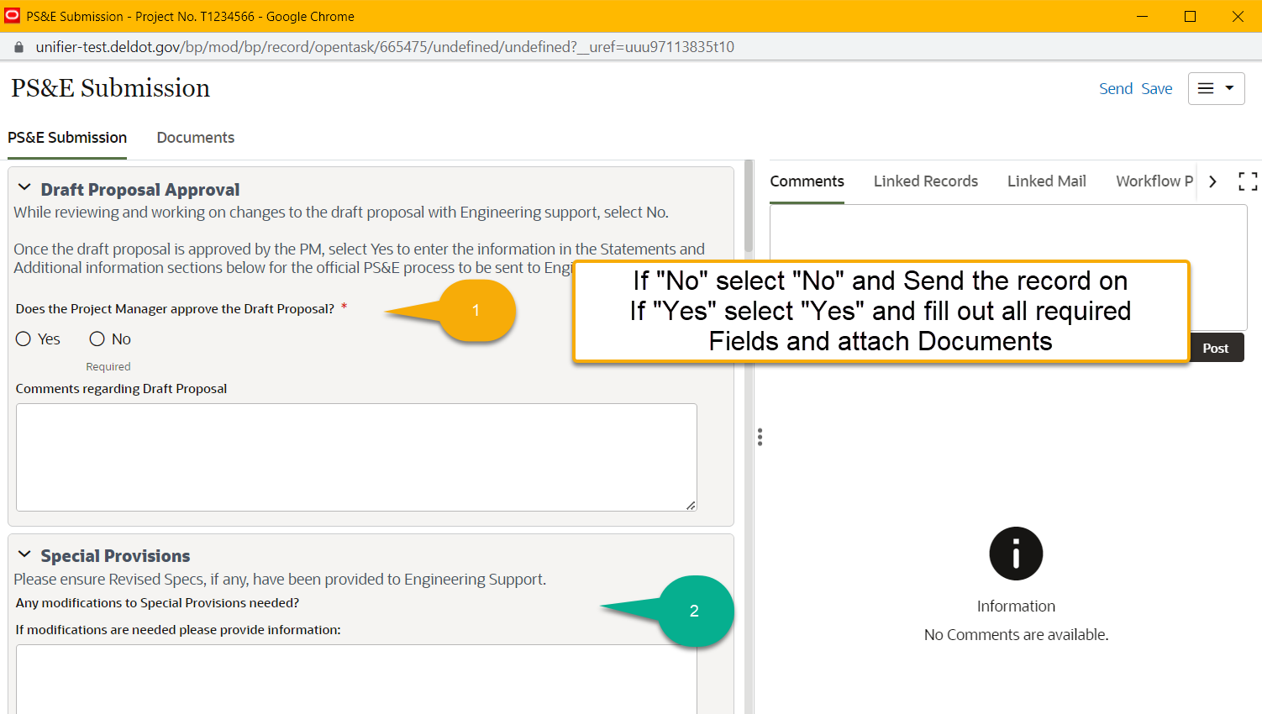
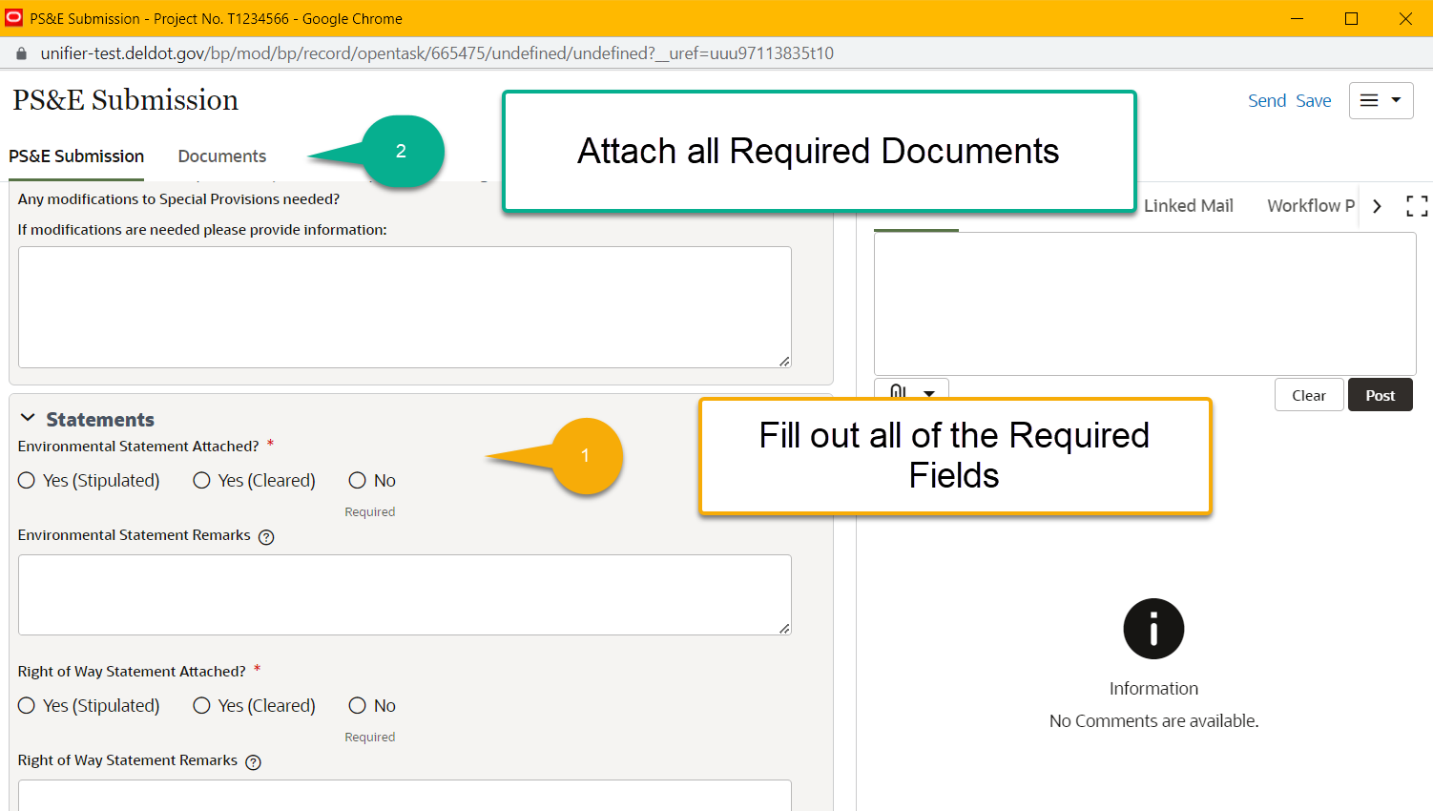
Creation

Edit

