Once you open up the project, click on the Field Documents on the Left-hand side. Then select the E&S Site Inspection.
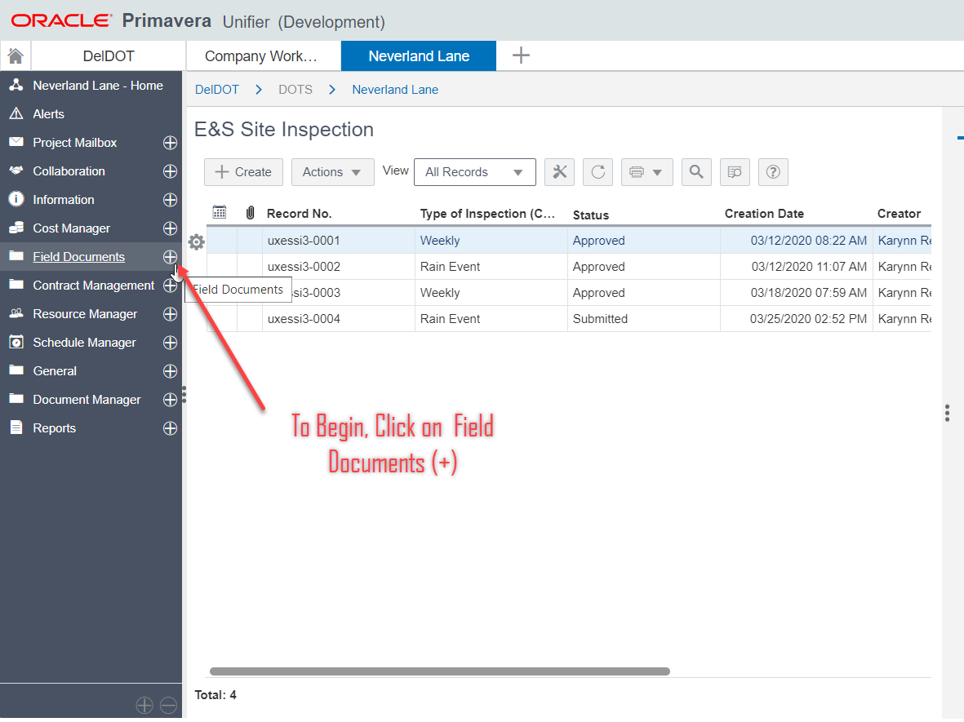
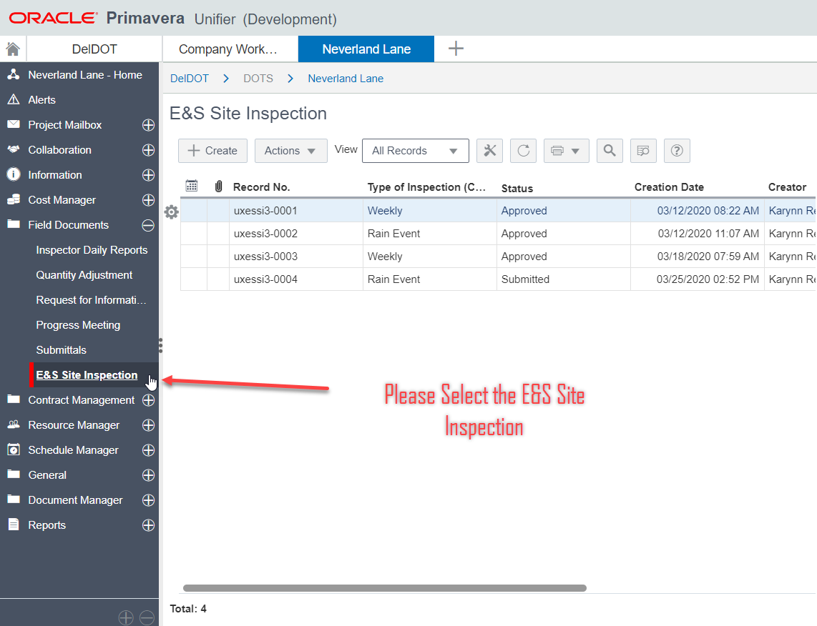

Then Click on Create to open the Site Inspection Form.
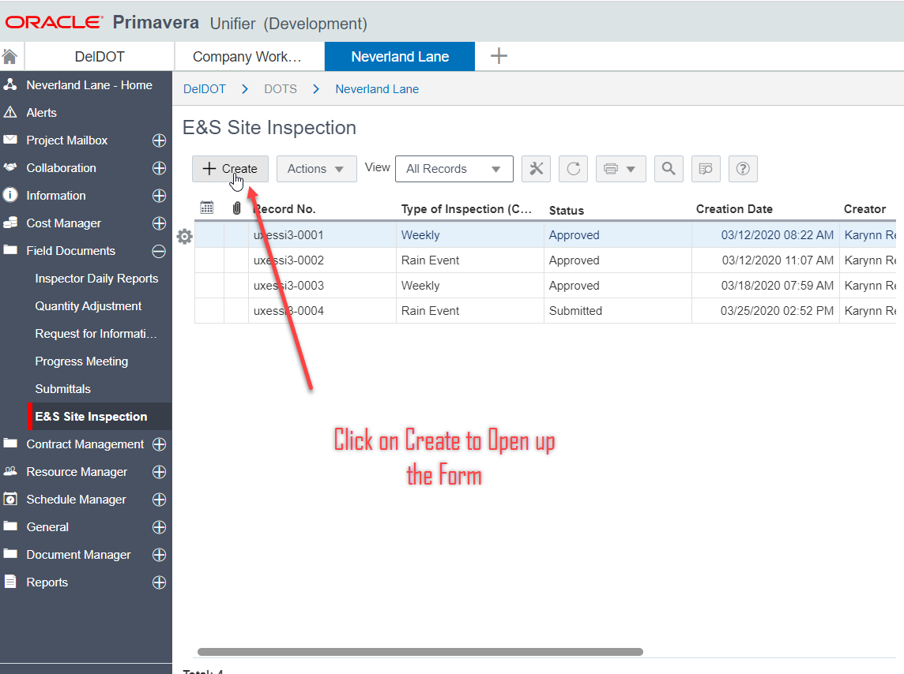
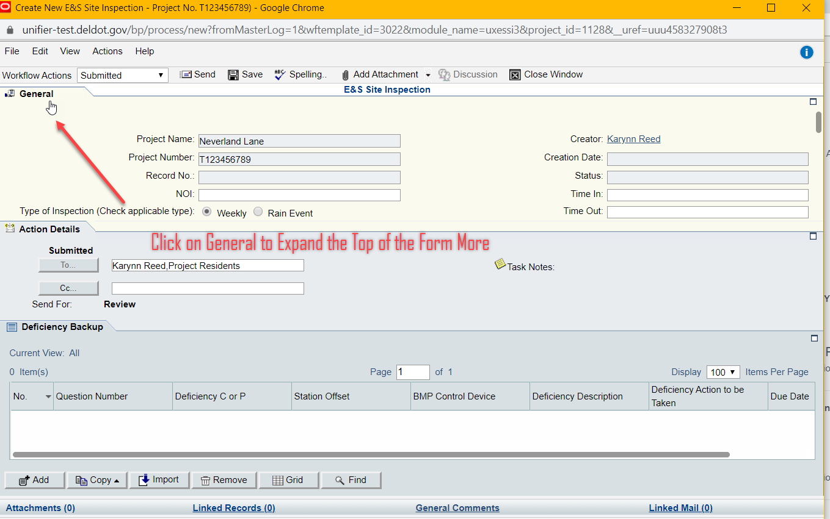

Clicking on the General Tab will expand that portion. Clicking on it a second time will once again minimize it.
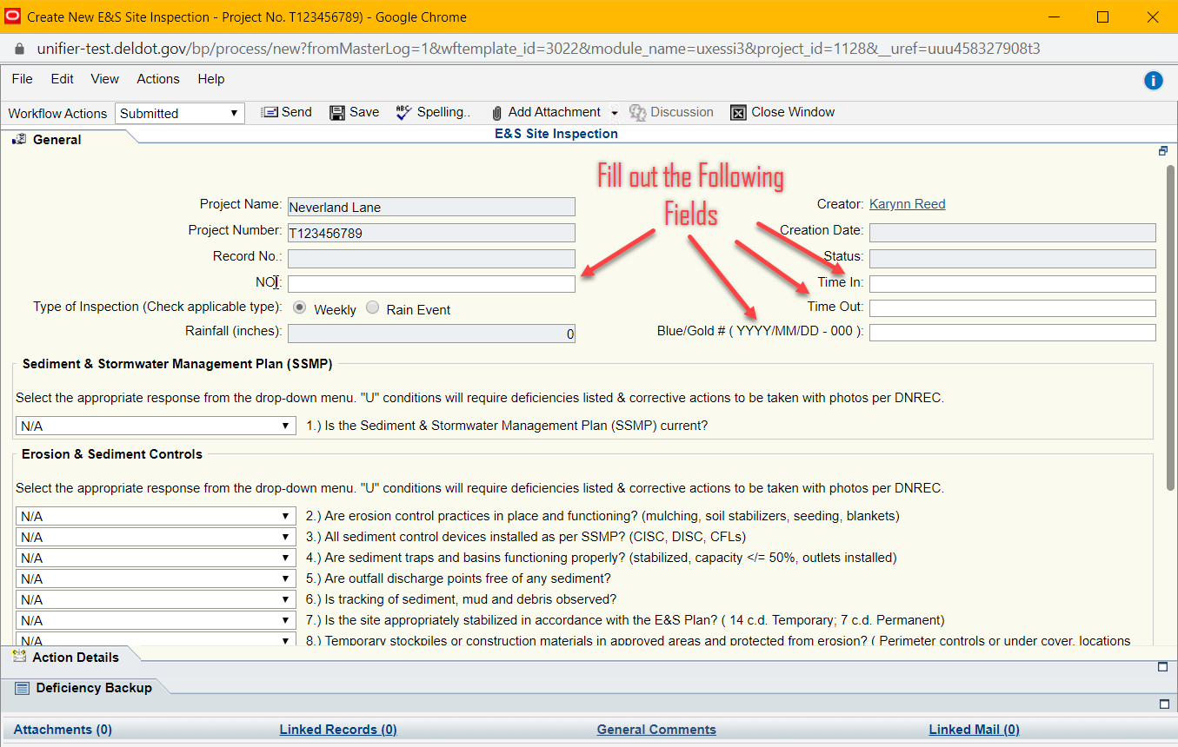

Greyed out areas are automatically filled such as Project Name, Number, Creator, Creation Date, Record Number, and Status. Fill out all of the Fields in the top portion.
Select the Inspection Type by clicking on one of the Radio Buttons “Weekly” or “Rain Event”. When Selecting Rain Event, the Rainfall Field will become Editable. Please note that if the “Rainfall” Field is filled out and Weekly is selected the information remains there. Please delete “Rainfall” Field if Weekly is selected. The “Rainfall” Field should remain Zero unless a “Rain Event” has occurred.
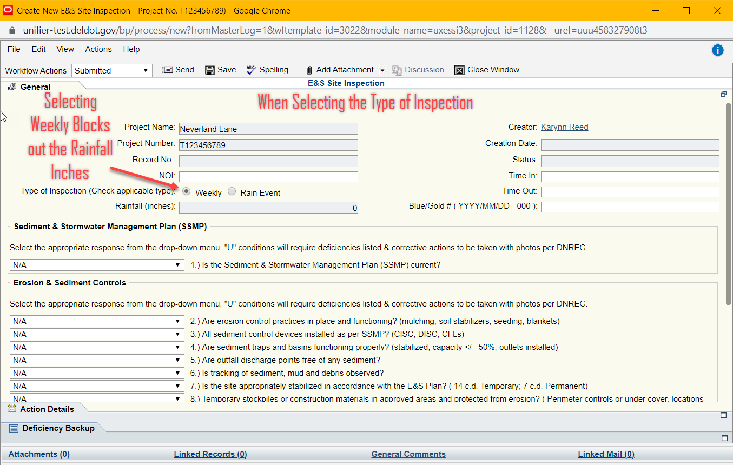
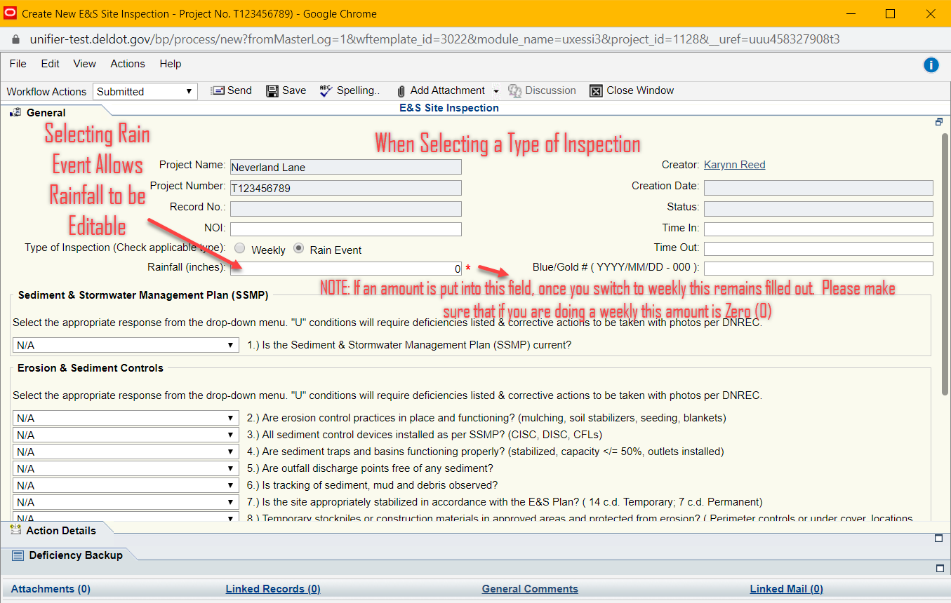
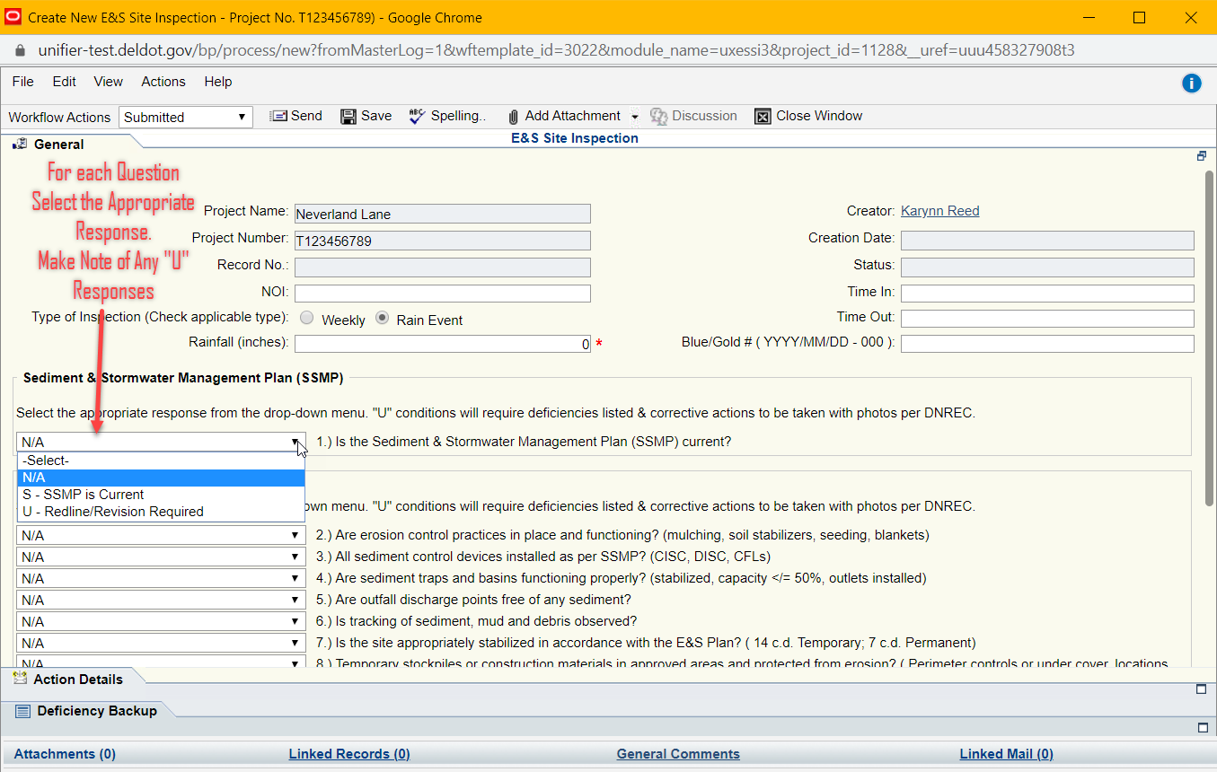
Answer each question by selecting the appropriate response from each Drop-Down. Make Note of any “U” responses. Each “U” response will require a Deficiency and corrective action including photos.
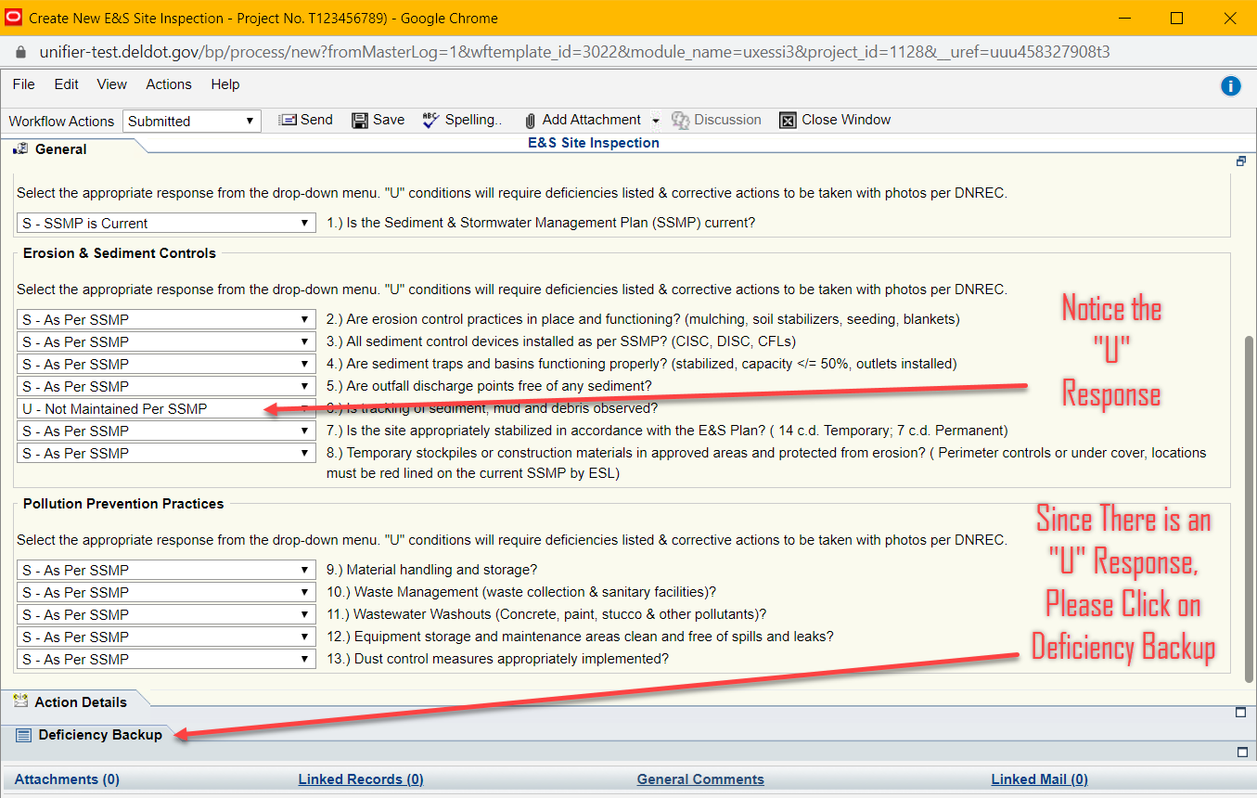
To Add a Deficiency, Click on the Deficiency Backup Tab to expand it. In the Bottom Left Corner, click on the Add button to add each Deficiency.
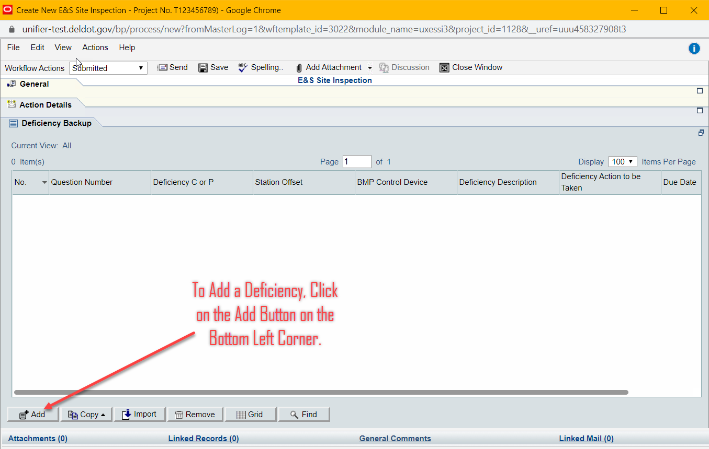
For each Question, fill out the corresponding drop downs and information. If you need to refer back to which questions had “U” responses Click on Save and Close and go back to the General Tab. Then go back to the Deficiency Backup tab to add the “U” responses in.
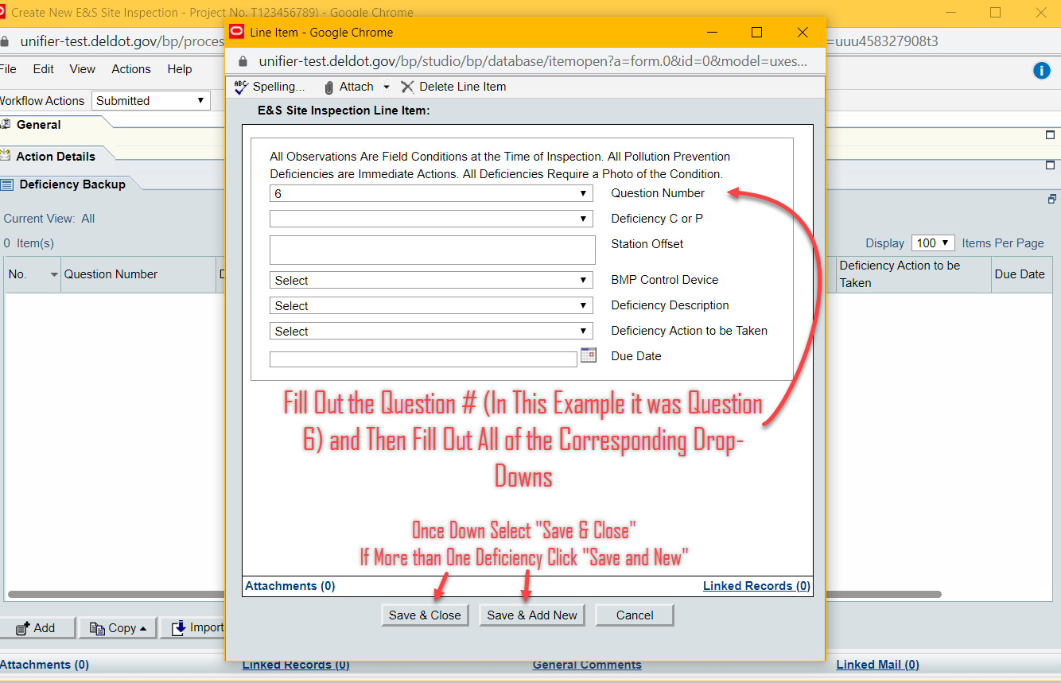
After all “U” responses have been recorded click on the Send button.
